2019
December 2022
Linn County Public and Environmental Health
4th Ave SW
Albany, OR 97321

2019

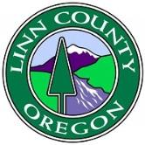
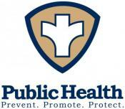
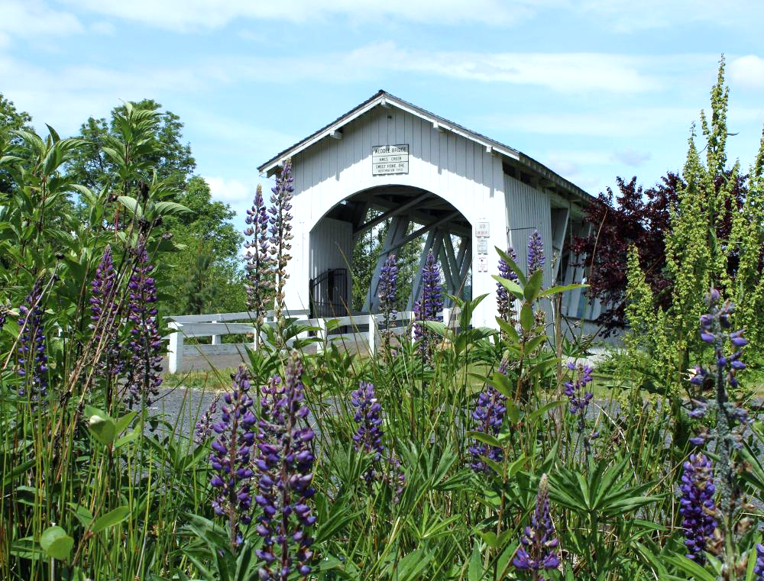
Linn County Health Services
Strategic Plan 2023-2025

Contents

Executive Summary 2
Development of the 2023-2025 Linn County Public and Environmental Health Strategic Plan 3
Project Outline and Timeline 4
Project Participants 5
The Focus of Strategic Planning 6
Building a Strategic Plan 7
Strategic Plan 8
Implementation of the Plan 9
Dissemination of the Plan 10

Executive Summary

Linn County Public and Environmental Health’s (LCPEH) Strategic Plan was drafted to guide Linn County Public and Environmental Health Programs leadership and staff over the next three years as they work together with community members to create and deliver effective, equitable, and quality county- wide Public Health services. The 2023-2025 Strategic Plan builds on the priority areas of the 2020-2022 strategic plan and the work accomplished by leadership, staff, and partners. The 2020-2022 Strategic Plan focused on:

- Infrastructure
- Financial Sustainability
- Access/Quality of Care
- Community & Partners

The 2023-2025 Linn County Public and Environmental Health Strategic Plan was developed with input from leadership, staff, and community members and facilitated by Partners in Participation.

2023-2025 Strategic Plan Vision
Our goal is to provide culturally proficient, responsive and responsible services for Linn County communities. Public and Environmental Health is prevention, promotion and protection for a better life.

Development of the 2023-2025 Linn County Public and Environmental Health Strategic Plan

The 2023-2025 Linn County Public and Environmental Health Strategic Plan was developed over the course of 2022. The process began in early 2022 with soliciting bids from experienced strategic planning facilitation firms. Partners in Participation (PiP) was selected and an internal design team was formed to work with PiP throughout the strategic planning process.
The Design Team included:
- Shane Sanderson, Public and Environmental Health Program Manager
- Rebecca Hall, Compliance and Privacy Officer
- Miao Zhao, Chair of the Public Health Advisory Committee
- Rachel Petersen, Health Promotions Supervisor
- Tyra Jansson, Communicable Disease Supervisor

Project Outline and Timeline
Together PiP facilitators and the design team agreed on the following project timeline to take place throughout 2022:
Timeframe | Activity | Responsible
Late February | Initial Intake; Co-Design session agendas | Design Team
Mid-March | Confirming dates and inviting planning participants | Linn County Public Health
April & ongoing | Develop detailed facilitation & production guides;  Develop collaborative workspaces on chosen platform (e.g. Miro) | Facilitators
April & ongoing | Provide a process to Linn County Public Health to help engage those who won’t be directly participating in the process | Design Team
July-September | Facilitate up to six planning sessions that include any of the following content based on Design Team input:  - Process Overview / Past Strategic Plan Progress Review  - Environmental Scan (what are the trends, paradigms, and approaches emerging in the field of public health?)  - Practical Vision (what would we like to see in place in 3 - 5 years?)  - Underlying Obstacles (what is blocking us from moving toward our vision?)  - Strategic Directions / Goals  - Implementation Planning  The Design Team will meet periodically between meetings to adjust course as necessary. They may also need to meet to refine some of the content that emerges from the facilitated sessions to prepare the following session. | Facilitators  Design Team
November | Facilitate a coordination session with Linn County Public Health team members who will be responsible for managing the strategic plan.  - This may also include a conversation about aligning the strategic plan with other key plans (e.g., workforce development, quality improvement, performance management, community health improvement)  - Training of Facilitators to lead progress monitoring and plan updates through quarterly check-ins and beyond. | Facilitators
November | - Provide a script  - Possible design for quarterly progress reporting and plan updates to be conducted by the designated team leads. | Facilitators

Project Participants
The design team worked to build a group for the planning sessions that would be holistic and include representatives from all teams, all levels of the Department of Health Services, the Diversity Committee for the Department of Health Services, the Public Health Advisory Committee, and community partners with whom Public and Environmental Health had contracted in 2021-2022.

Public Health Advisory Board | Miao Zhao | Fabiola Herrera | Tina Dodge
Women, Infant, and Children (WIC) Team | Leah Brunson | Megan Dunn | Serena Stearns- Garland
Maternal Child Health (MCH) Team | Monica Boylan | Emily Middleton | Janie Tabeau
Communicable Disease (CD) Team | Tyra Jansson | Celine Coleman | Edgar Zarazua
Health Promotions (HP) Team | Rachel Petersen | Audrey Caro | Diego Nieto
Environmental Health (EH) Team | Shane Sanderson | Nate Tisdell | Sydney Jones
Administration | Rebecca Hall | Diana Denham
Diversity Committee for Department of Health Services | Rebecca Torres | Sandi Sabedra
Community Partners | Casa Latinos Unidos | GAPS

The Focus of Strategic Planning
PiP facilitators and the Design team used the following definitions to establish a clear foundation as to what strategic planning is, what makes it unique, and what the process should focus on. Strategic Planning is focused on the desired future of the organization itself and focused on strategic work. It is not the things that we are already committed to – unless one of those things needs a push or special attention.
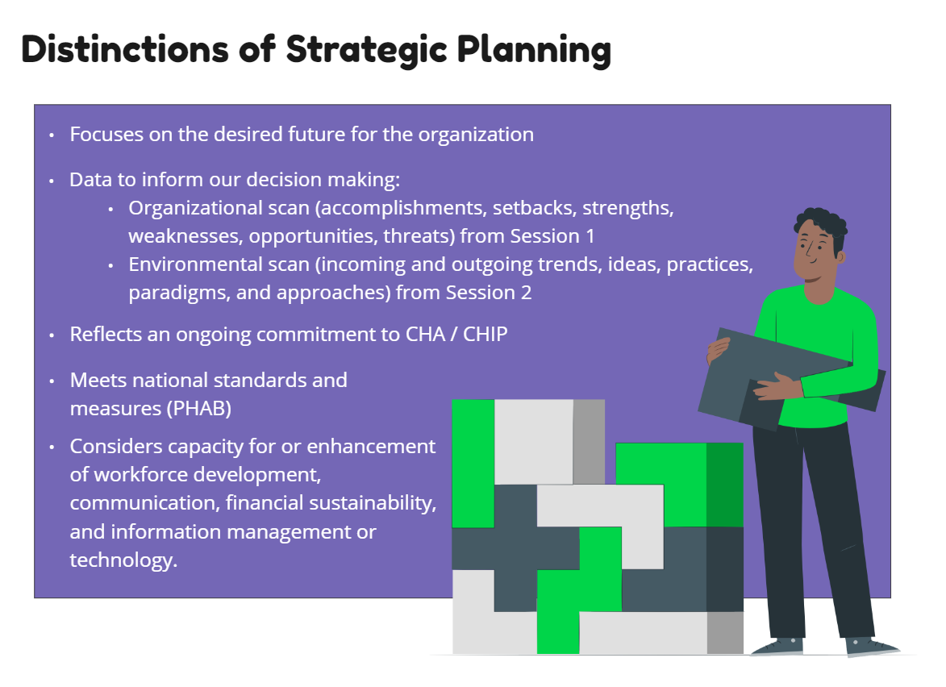
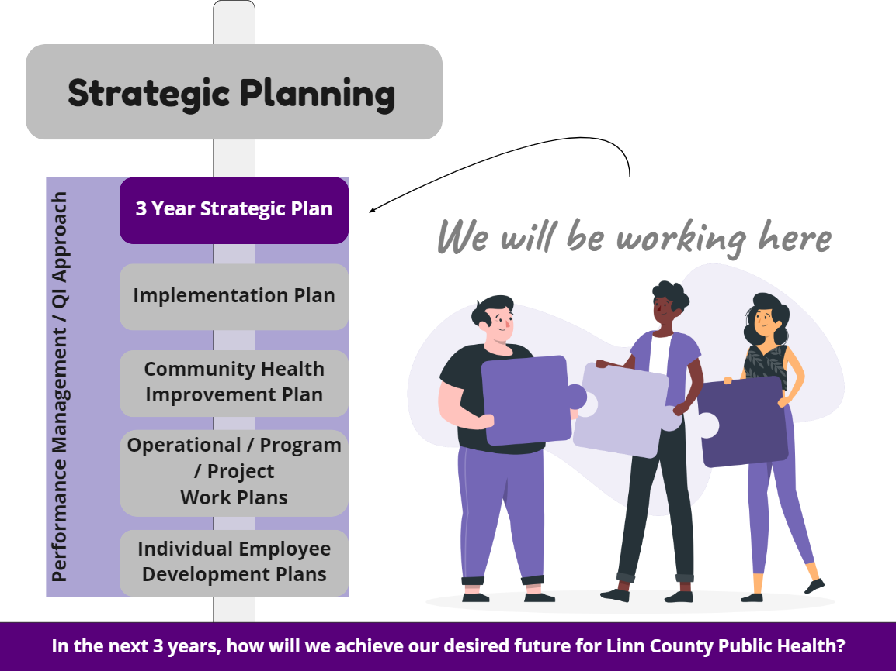

Building a Strategic Plan
Through six sessions, the facilitators of PiP led the participants through the cycle reflected below using structured reflections, discussions, and prioritizations.

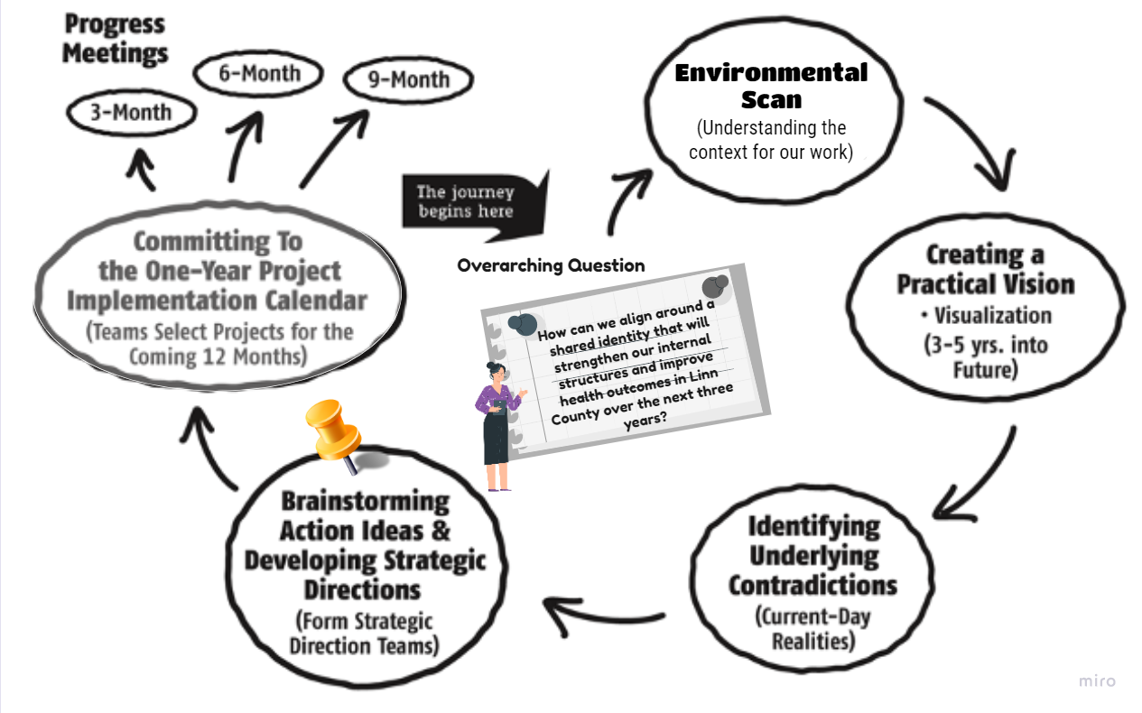

Throughout the process, four priority areas emerged along with vision statements, actionable items, and a plan for implementation and re-visioning.
Included in the next section of this document are the priority areas, strategies, and objectives developed as of December 2022. Strategic plans are living documents and this document will be updated to reflect the successes and re-visioning that will take place over the next three years.

Strategic Plan

2023-2025 Strategic Plan Vision Statement
Our goal is to provide culturally proficient, responsive and responsible services for Linn
County communities. Public and Environmental Health is prevention, promotion and protection for a better life.

Goal: Advance activities that will promote greater communication and  information sharing among internal staff and Linn County community  members. | Workforce Development Alignment:
Strategy: Build our brand and community trust through consistent and accessible external communication
Strategy: Communicate regularly as an interconnected department

Goal: Have a highly trained, diverse, and effective workforce with standardized policies and procedures based on best business practices. | Workforce Development Alignment:
Strategy: Equip our staff to practice competently in relevant policies and
procedures through onboarding and training
Strategy: Support our staff with a clear HR structure and policies

Goal: Establish sustainable funding to build community trust. | Workforce Development Alignment:
Strategy: Ensure equitable access to reproductive health care
Strategy: Improve our grant writing capacity to sustain funding and capitalize on funding opportunities
Strategy: Build community trust & connections to community partners through health navigation program

Goal: Nurture an inclusive environment for all employees with a spirit of continuous learning and improvement, measured by clear metrics, and  supported by equitable allocation of time and access to evidence- based resources. | Workforce Development Alignment:
Strategy: Nurture a spirit of learning and improvement by providing equitable access to training and influence
Strategy: Allocate time for employees to focus on improvement work with clear metrics

Implementation of the Plan

The 2023-2025 Linn County Public and Environmental Health Strategic Plan will be signed and officially adopted by the Program Manager and Health Administrator. It will also be shared with the Linn County Public Health Advisory Board and all Department of Health Services staff. A copy of the Strategic Plan will be available to the public on the Linn County Public Health website. An annual update on the Strategic Plan will be provided to these audiences every January.
The Program Manager will oversee the maintenance and implementation of the strategic plan through utilizing 90 day plans and assigning co-leads to each priority area. The co-leads will be responsible for setting the 90 day plan for their priority area, tracking the work, and reporting on the goals and barriers at the end of the 90 days. The co-leads will be responsible for crafting the next 90 day plan.

Dissemination of the Plan
The completed plan will be presented to:
- Public and Environmental Health All Staff
- Department of Health Services Diversity Committee
- Public Health Advisory Committee
A copy of the Strategic Plan will be available to the public on the Linn County Public Health website in English and Spanish.
An annual update on the Strategic Plan will be provided to these audiences every January. This update will be reflected in the document and updated and translated copies will be placed on the Linn County Public Health website.

